Experiment No. 1 Generation and Classification of Continuous-Time and Discrete-Time Signals
OBJECTIVE:
(i) To generate and visualize basic continuous-time signals such as unit step, unit impulse, ramp, sinusoidal, and exponential signals.
(ii) To generate and visualize basic discrete-time signals and analyze their amplitude and time index characteristics.
(iii) To generate and classify continuous-time and discrete-time signals as periodic or aperiodic based on their periodicity characteristics.
(iv) To decompose a given signal into its even and odd components and verify the reconstruction of the original signal.

(i) To generate and visualize basic continuous-time signals such as unit step, unit impulse, ramp, sinusoidal, and exponential signals.
Procedure
1. Define a continuous time vector with a sufficiently small simulation interval. 2. Generate unit impulse, unit step, ramp, exponential and sinusoidal signals. 3. Plot each waveform against time using suitable amplitude and time scales. 4. Measure amplitude, frequency and period wherever applicable.
5. Compare the simulated waveform with its theoretical expression.
6. Record observations and justify the signal characteristics.
Matlab Coding:
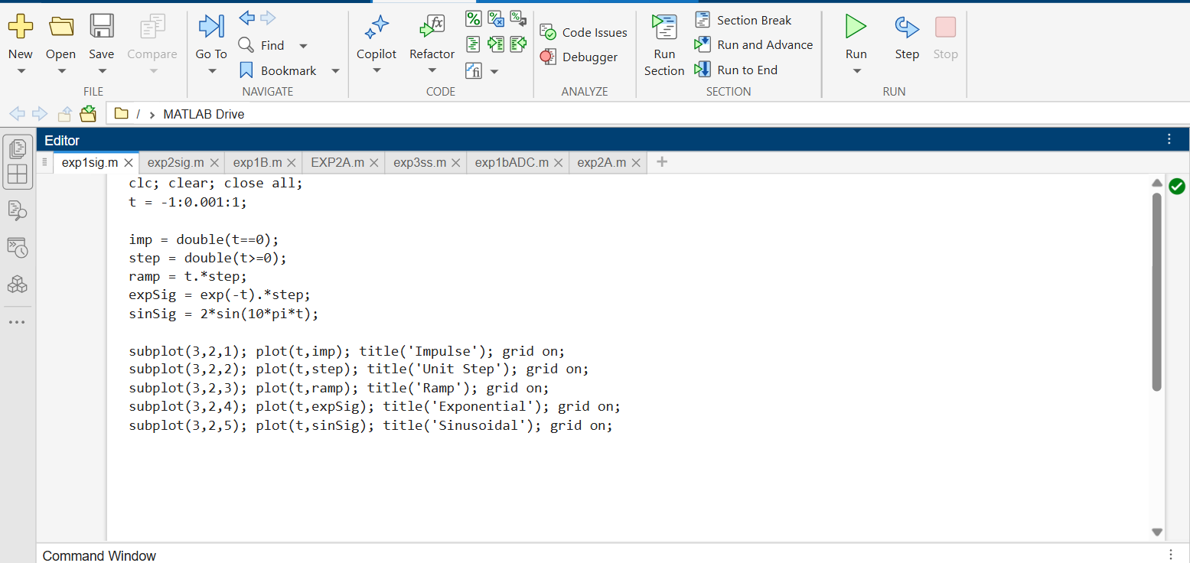
Output:
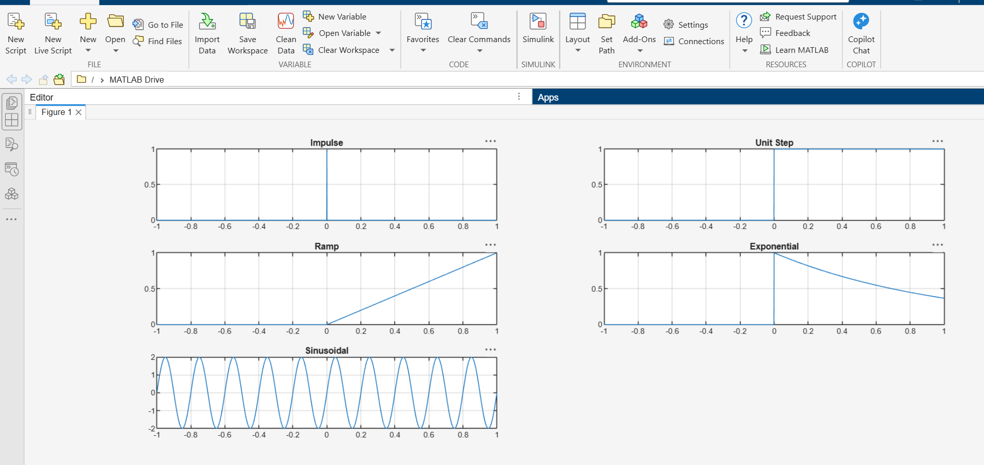

(ii) To generate and visualize basic discrete-time signals and analyze their amplitude and time-index characteristics.
Experimental Procedure
1.Define the integer sample index n.
2.Generate unit impulse, unit step, ramp, exponential and sinusoidal sequences.
3.Display each sequence using a stem plot.
4.Determine sample amplitudes and period where applicable.
5.Classify the sequence as periodic/non-periodic and even/odd wherever applicable.
6.Compare the generated samples with theoretical values and record observations.
Matlab Coding:
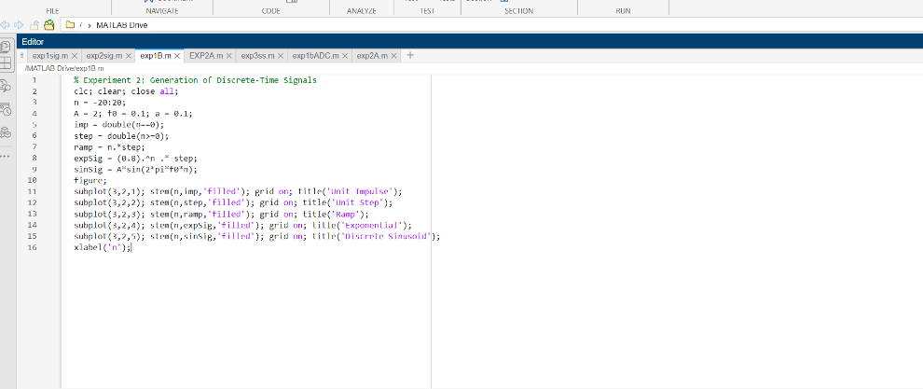

Output:
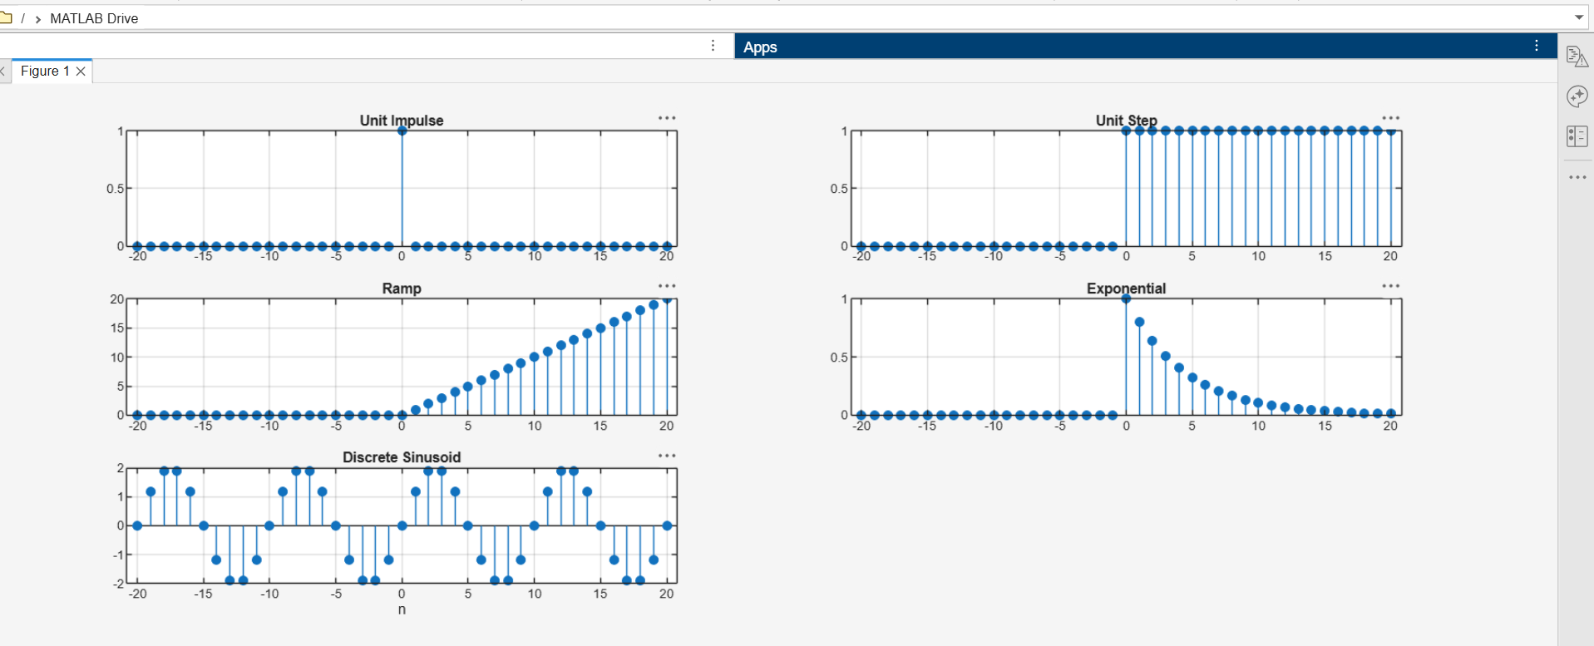
(iii) To generate and classify continuous-time and discrete-time signals as periodic or aperiodic based on their periodicity characteristics.
Experimental Procedure:
1. Generate a sinusoidal signal with a known frequency.
2. Generate an aperiodic decaying exponential signal.
3. Plot both signals over the same or suitable time range.
4. Measure the interval between corresponding points of successive cycles for the periodic signal.
5. Check whether a finite non-zero period can satisfy the periodicity condition for the aperiodic signal.
6. Record the classification and justification.
Matlab Coding:
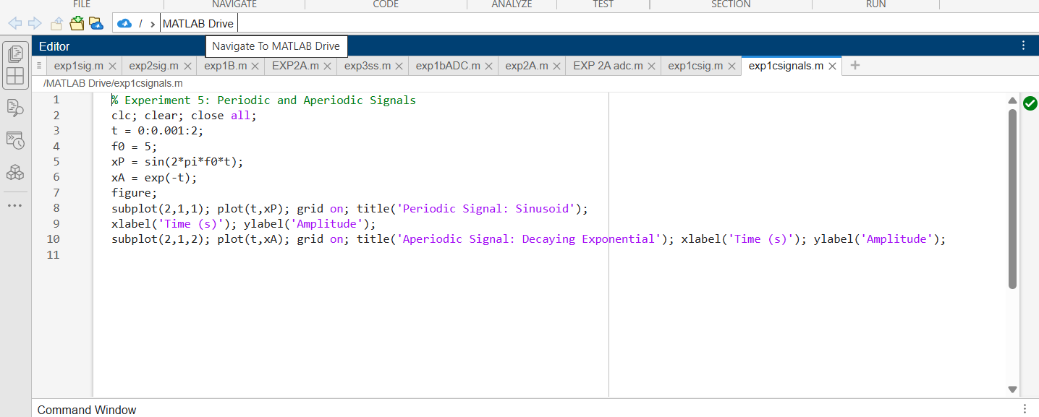
Output:
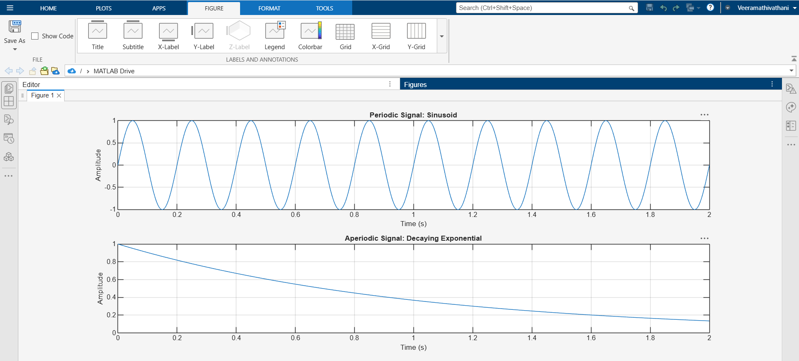

(iv) To decompose a given signal into its even and odd components and verify the reconstruction of the original signal.
Experimental Procedure:
1. Define the time vector and generate x(t).
2. Generate the time-reversed signal x(−t).
3. Calculate the even and odd components using the standard expressions. 4. Plot x(t), xe(t) and xo(t).
5. Verify symmetry and anti-symmetry about t=0.
6. Add xe(t) and xo(t) and compare with x(t).
7. Calculate the maximum or RMS reconstruction error.
Matlab Coding:

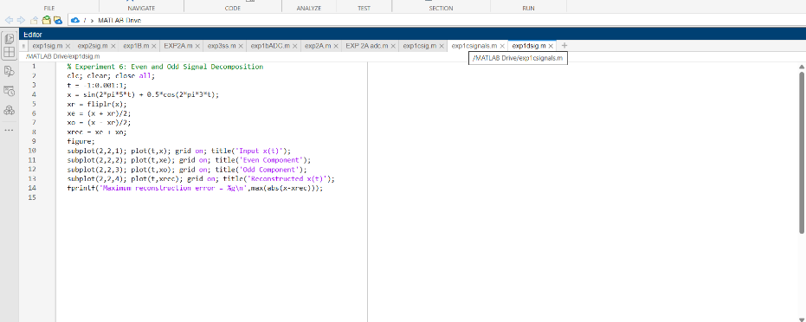

Output:
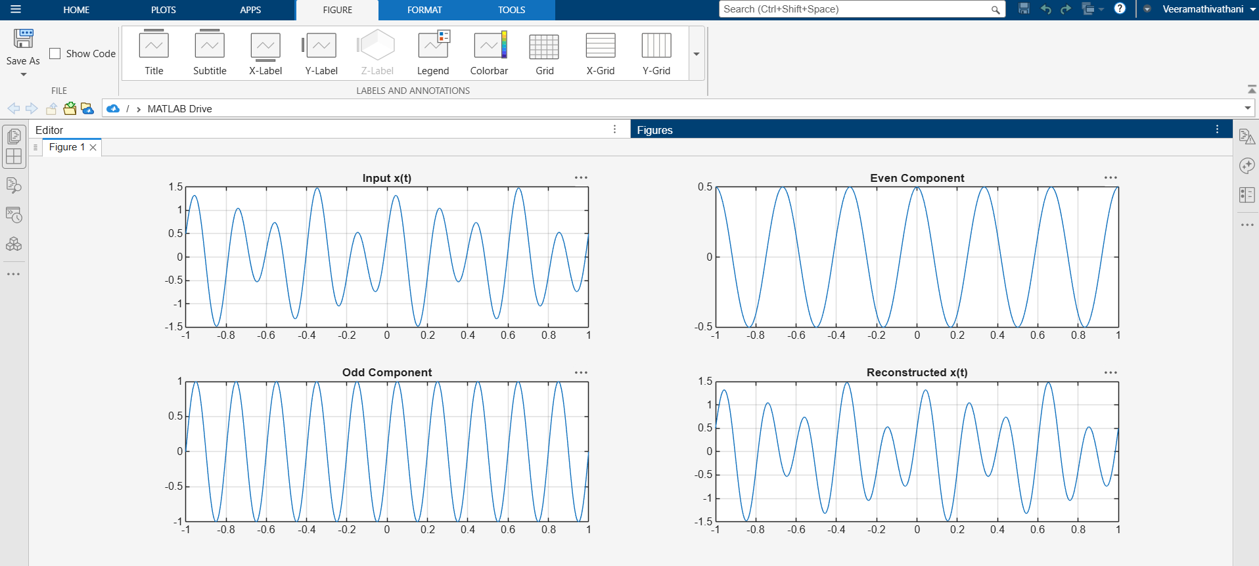
Result:
The continuous-time and discrete-time signals were generated and analyzed successfully. The signals were classified as periodic or aperiodic, and the even and odd components were obtained and used to reconstruct the original signal successfully.

